**TSQL Homework 04**

**Question 1**

In your own words, what is a subquery?

**Answer**

It is a query that is nested inside a SELECT and WHERE clause, or inside another subquery. A subquery can be used anywhere an expression is allowed.

**Question 2**

In your own words, what is a self-contained subquery?

**Answer**

A self-contained subquery has no dependency on tables from the outer query. It is a standalone query. Subqueries is a feature where you want one query to operate on the result of another query. Subqueries are either self-contained or correlated. A self-contained subquery is independent of the outer query. A scalar subquery returns a single value.

**Question 3**

In your own words, what is correlated subquery?

**Answer**

A correlated subquery (also known as a synchronized subquery) is a subquery (a query nested inside another query) that uses values from the outer query.

**Question 4**

Give an example of a subquery that returns a single value. When would you use this kind of subquery?

**Answer**

A scalar subquery is a subquery that returns a single value.

Select unitprice, (select avg(od.unitprice) from sales.orderdetails od) from sales.orderdetails

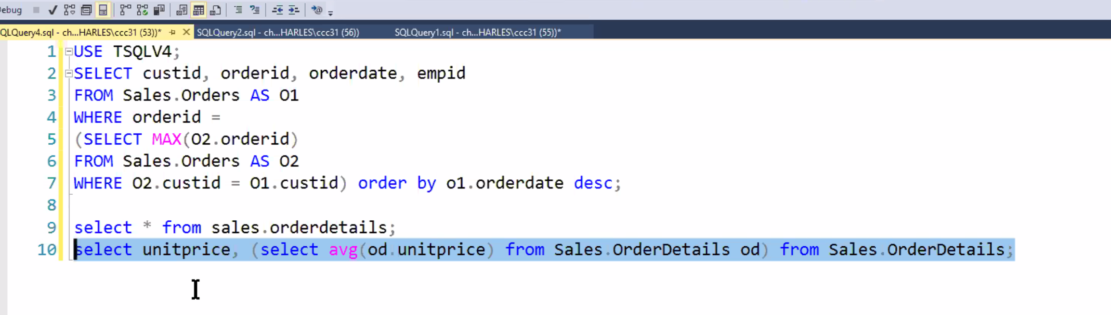

**Question 5**

Give an example of subquery that returns multiple values. When would you use this kind of subquery?

**Answer**

A multivalued subquery is a subquery that returns multiple values as a single column. Some predicates such as the IN predicate, operate on a multivalued subquery.

SELECT orderid

FROM sales.orders

WHERE empid IN

(SELECT E.empid

FROM HR.Employees AS E

WHERE E.lastname LIKE N’D%’);

**Question 6**

Give an example of a subquery that returns table values. When would you use this kind of subquery?

**Answer**

When the subquery returns one or more rows of values, the subquery is only evaluated once and then the row(s) of values is returned to outer query to use. Row subquery is MySQL specific.

**Question 7**

What does the exists predicate do? Give an example.

**Answer**

The EXISTS predicate can be used to check for the existence of specific rows. The query_expression returns rows rather than values. The predicate evaluates to true if the number of rows returned by the query_expression is non-zero.

**Question 8**

What happens if we use the not operator before a predicate? Give an example.

**Answer**

If you place it before a predicate it negates it. Shows the people who did not place orders.

**Question 9**

When you use exists or not exists with respect to a row in a database, does it return two or three values? Explain you answer.

**Answer**

Kk

**Question 10**

How would you use a subquery to calculate aggregates? For example, you want to calculate yearly sales of a product, and you also want to keep a running sum of total sales. Explain how you would use a subquery to do this.

**Answer**

A subquery can also be found in the SELECT clause. These are generally used when you wish to retrieve a calculation using an aggregate function such as the SUM, COUNT, MIN, or M